**Practical No. 1**

***Aim (Practical Outcome):-*** Write a program to draw following graphics objects using built in “C” functions. (Pixel, Lines, Circles, Rectangle, Ellipse.)

***Relevant Course Outcome(s):-***

Identify the file structure of display graphics file formats.

***Resources Required (Hardware & Softwares):-***

1. A Desktop PC/ Laptop
2. Ansi C/ Turbo C/ (Any distribution) installed

***Theoretical Background:-***

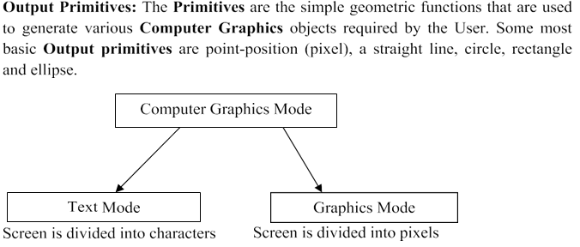

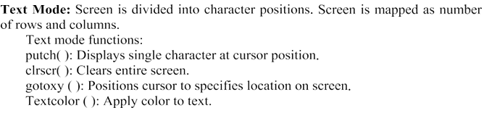

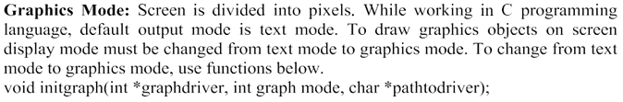

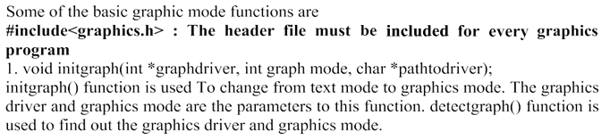

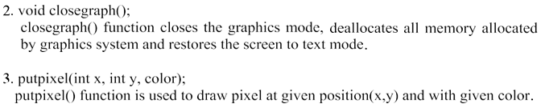

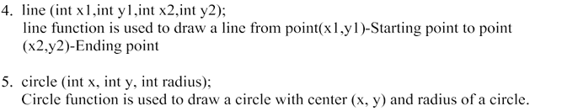

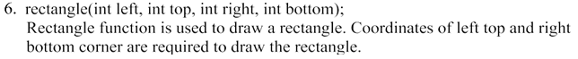

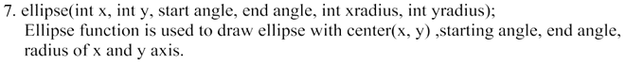



***Algorithm/ Steps to be performed:-***

1. List different basic graphics functions.
2. Select the proper function to draw respective object.
3. Use proper syntax for selected function.
4. Check the required format of output.

***Program*:**

#include <graphics.h>

#include <conio.h>

int main() {

int gd = DETECT, gm;

initgraph(&gd, &gm, "C:\\Turboc3\\BGI");

putpixel(100, 100, WHITE);

line(150, 150, 300, 150);

circle(200, 200, 50);

rectangle(100, 300, 300, 400);

ellipse(300, 300, 0, 360, 100, 50);

getch();

closegraph();

return 0;

}

**Output : - ( Paste your own Output )**

***Conclusion:-***

Thus, we have executed a program to draw graphics objects, Pixel, Lines, Circles, Rectangle, Ellipse using built in “C” functions.